

**2**

**Template**

# Brainstorm

#### Write down any ideas that come to mind that address your problem statement.

##### 10 minutes

**3**

# Group ideas

**TIP**

You can select a sticky note and hit the pencil [switch to sketch] icon to start drawing!

#### Take turns sharing your ideas while clustering similar or related notes as you go. Once all sticky notes have been grouped, give each cluster a sentence-like label. If a cluster is bigger than six sticky notes, try and see if you and break it up into smaller sub-groups.

##### 20 minutes

**4**

# Prioritize

#### Your team should all be on the same page about what's important moving forward. Place your ideas on this grid to determine which ideas are important and which are feasible.

**20 minutes**

# After you collaborate

#### You can export the mural as an image or pdf to share with members of your company who might find it helpful.

###### PERABATHULA VENKATA SITA MAHA LAKSHMI

nd send an head.

solving in

py and

SUPPLY OF SUFFICIENT SEEDS AND FERTILIZER

**PRADEEP C J**

THE HIGH YIELD CROPS REQUIRE MORE WATER AND FERTILIZERS

**Quick add-ons**

SOLID TESTING AND ITS QUALITY

MONITORING CROPS GROWTH

###### PRANESHWAR K

To Visualize the trends in the dataset

IMPROVEMENT IN AGRICULTURAL ACCURACY

THE FOOD REQUIREMENTS CAN MANAGE TO EXTEND THE POSSIBLE BY INCREASING AREA UNDER

CULTIVATION

To Showcase the Yearly usage of Area in Crop Production

Try to identify the dataset containing the various types of crops and their yields

**RAGUL J**

IT'S HELPS US TO UNDERSTAND FOOD SECURITY

**Understanding Data**

To identify the crop patterns over different seasons

PLANTING CROPS IN THE RIGHT TIME IS VERY EFFECTIVE IN INCREASING CROP YIELD

To know about Various seasonal, economic and biological factors that infuence the crop production.

Data Acquisition

IMPERMANENT LOSS MAY INFLICT PERMANENT DAMAGE

To get the insights from the dataset

**TIP**

Add customizable tags to sticky notes to make it easier to find, browse, organize, and categorize important ideas as themes within your mural.

**Data Analysis and Prediction**

To estimate the yield of a particular crop in different areas.

The risks can be measured when suitable mathematical and statistical model designs are applied on data related to soil, weather and past yield

## Importance

To Visualize the trends in the dataset

If each of these tasks could get done without any difficulty or cost, which would have the most positive impact?

To identify the crop patterns over different seasons

To predict the accurate crop yield such that it certainly benefts the farmers in choosing the right method to

reduce the crop damage and gets best prices for their crops

To collect the data on world climatic changes and the available water resources which can be used to encourage advanced and novel approaches such as big data analytics to retrieve the information of the previous results to the crop yield prediction and estimation

To know about Various seasonal, economic and biological factors that infuence the crop production.

The risks can be measured when suitable mathematical and statistical model designs are applied on data related to soil, weather and past yield

Get the historical Data about the crop yield in different regions of India

To identify the crop patterns over different seasons

### Try to identify the dataset containing the various types of crops and their yields

###### Share the mural

**Share a view link** to the mural with stakeholders to keep them in the loop about the outcomes of the session.

###### Export the mural

Export a copy of the mural as a PNG or PDF to attach to emails, include in slides, or save in your drive.

To get the insights from the dataset

## Keep moving forward

###### Strategy blueprint

Define the components of a new idea or strategy.

###### [Open the template](https://app.mural.co/template/e95f612a-f72a-4772-bc48-545aaa04e0c9/984865a6-0a96-4472-a48d-47639307b3ca)

**Customer experience journey map**

Understand customer needs, motivations, and obstacles for an experience.

###### [Open the template](https://app.mural.co/template/b7114010-3a67-4d63-a51d-6f2cedc9633f/c1b465ab-57af-4624-8faf-ebb312edc0eb)

**Strengths, weaknesses, opportunities & threats**

Identify strengths, weaknesses, opportunities, and threats (SWOT) to develop a plan.

|  |  |
| --- | --- |
|  |  |
|  |  |

###### [Open the template](https://app.mural.co/template/6a062671-89ee-4b76-9409-2603d8b098be/ca270343-1d54-4952-9d8c-fbc303ffd0f2)

To collect the data on world climatic changes and the available water resources which can be used to encourage advanced and novel approaches such as big data analytics to retrieve the information of the previous results to the crop yield prediction and estimation

To build a responsive dashboard to analyse and estimate crop yield using data analytics.

To Build a visualization to show case top 10 States in Crop Yeild Production by Area.

Try to identify the dataset containing the various types of crops and their yields

**TIP**

Participants can use their cursors to point at where sticky notes should go on the grid. The facilitator can confirm the spot by using the laser pointer holding the **H key** on the keyboard.

To predict the accurate crop yield such that it certainly benefts the farmers in choosing the right method to

reduce the crop damage and gets best prices for their crops

###### [Share template feedback](https://muralco.typeform.com/to/CiqaHVat?typeform-source=app.mural.co)

RISK OF LOSS THAT CANNOT BE COMPENSATION

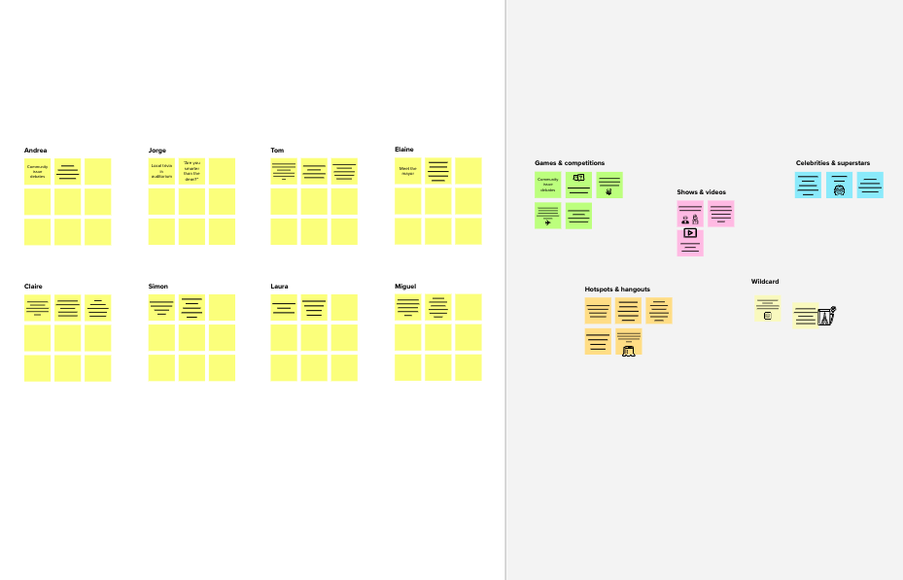

**Before you collaborate**

A little bit of preparation goes a long way with this session. Here’s what you need to do to get going.

**10 minutes**

1. **Team gathering**

Define who should participate in the session a invite. Share relevant information or pre-work a

1. **Set the goal**

Think about the problem you'll be focusing on the brainstorming session.

**1**

**Define your problem statement**

What problem are you trying to solve? Frame your problem as a How Might We statement. This will be the focus of your brainstorm.

**5 minutes**

**C Learn how to use the facilitation tools**

Use the Facilitation Superpowers to run a hap productive session.

[**Open article**](https://support.mural.co/en/articles/2113740-facilitation-superpowers)

**Key rules of brainstorming**

To run an smooth and productive session

Stay in topic.

Encourage wild ideas.

Defer judgment.

Listen to others.

Go for volume.

If possible, be visual.

**Need some inspiration?**

See a finished version of this template to kickstart your work.

[**Open example**](https://app.mural.co/template/e5a93b7b-49f2-48c9-afd7-a635d860eba6/93f1b98d-b2d2-4695-8e85-7e9c0d2fd9b9)

**PROBLEM**

**To Estimate the Crop Yield using Data Analytics**

[**Share template feedback**](https://muralco.typeform.com/to/CiqaHVat?typeform-source=app.mural.co)

**10 minutes** to prepare

**1 hour** to collaborate

**2-8 people** recommended

**Brainstorm**

**& Idea prioritization**

Use this template in your own brainstorming sessions so your team can unleash their imagination and start shaping concepts even if you're not sitting in the same room.

Get the historical Data about the crop yield in different regions of India

## Feasibility

Regardless of their importance, which tasks are more feasible than others? (Cost, time, effort, complexity, etc.)